|  |  |  |  |  |  |
| --- | --- | --- | --- | --- | --- |
| Date | 7-Dec-22 | | | Tester Name | Richard Belanger |
| Environment | Penfax - Test | | | Login used | TEST2 |
| Operating System | Windows | Version: | Update: | | |
| Software Used | Edge | Version: | Update: | | |
| Select Software | Version: | Update: | | |
| Release version | 22.4.1 | | | | |
| Title | M28.07 Miscellaneous | | | | |
| Test Type | Regression | | | | |
| Test Scenario | Run Data Posting and Remittance Report | | | | |
|  |  | | | | |
| Expected Results | The report will show differences between the Remittance and Data Posting Reports, if any | | | | |
| Pass/Fail | Pass | | | JIRA# | N/A |

Describe your steps with screenshots:

In Accounting module, select Remittance Management,then Select Data Postings vs Remittances Report

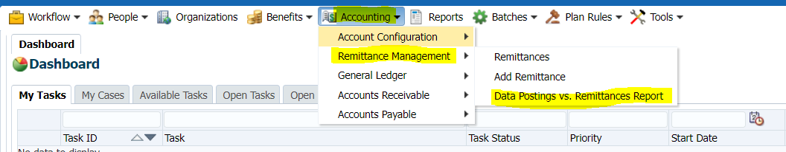

**Select Plan = MEPP; Employer = City of North Battleford; Pay Period End Date = All; Pay Date = All**

Click Run Report

